Topic 2

1. Write a program to perform the following
An empty list
A list with one element
A list with all identical elements
A list with negative numbers
Test Cases:
1. Input: []
• Expected Output: []
1. Input: [1]
• Expected Output: [1]
2. Input: [7, 7, 7, 7]
• Expected Output: [7, 7, 7, 7]
3. Input: [-5, -1, -3, -2, -4]
• Expected Output: [-5, -4, -3, -2, -1]

Aim: To write a C program to sort a list of integers in ascending order and test it with:
- An empty list
- A list with one element
- A list with all identical elements
- A list with negative numbers

Screen shots of code:
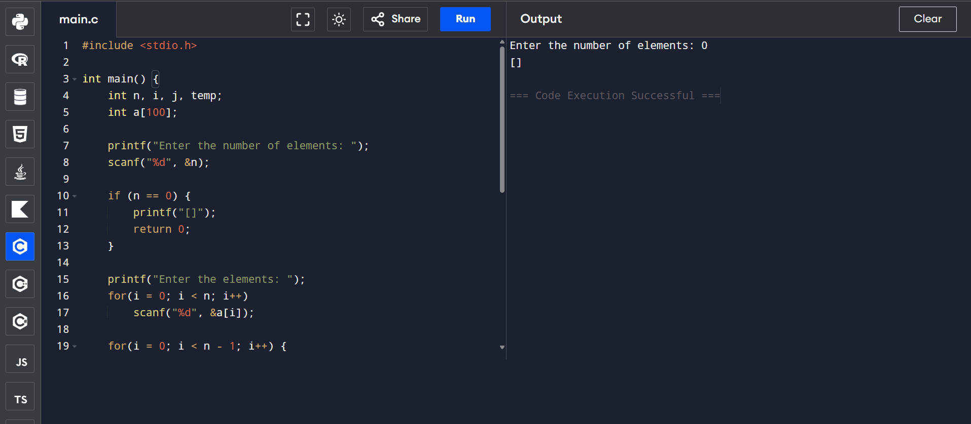
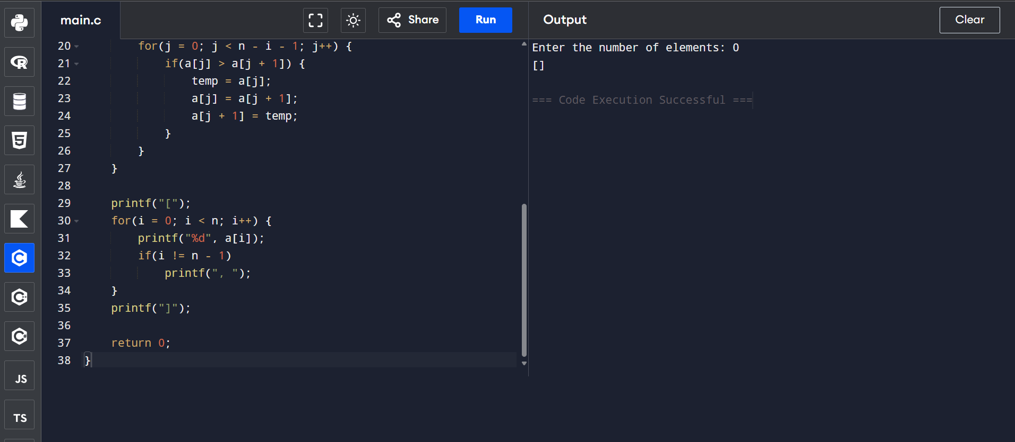
Test Case 1: Empty List
Input:
Enter the number of elements: 0
Output:
[]
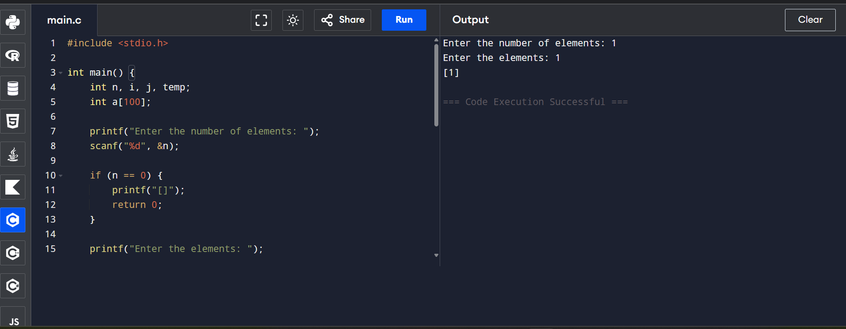
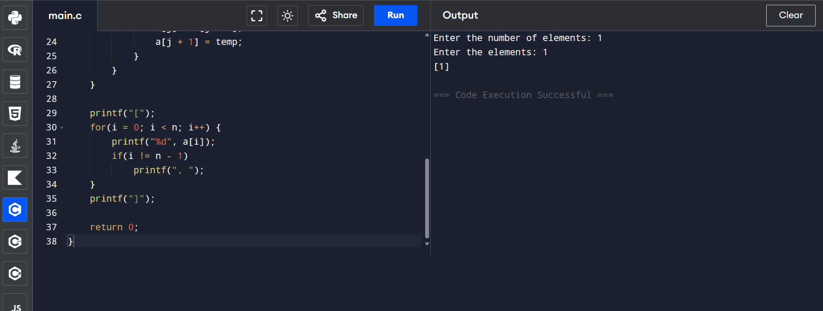
Test Case 2: One Element
Input:
Enter the number of elements: 1
Enter the elements: 1
Output:
[1]
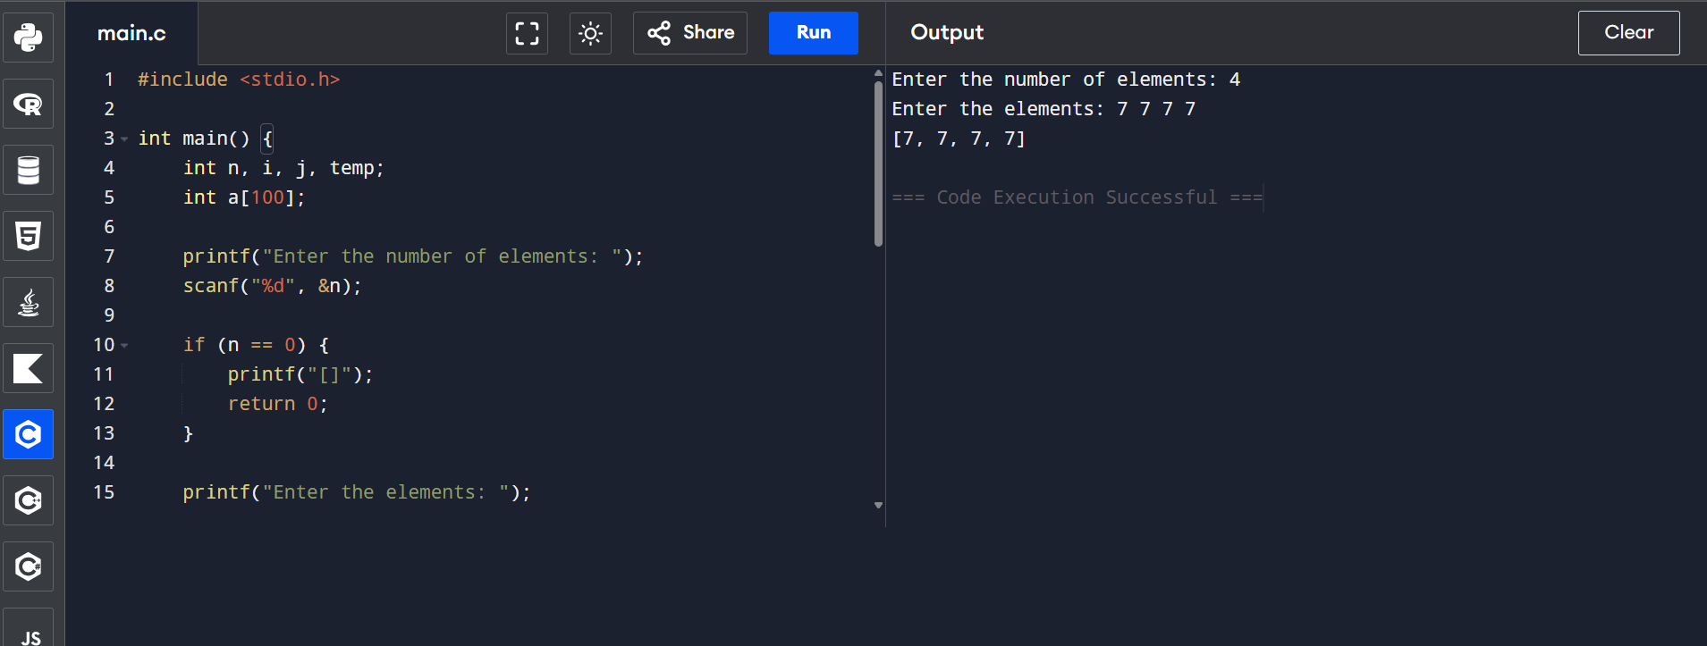
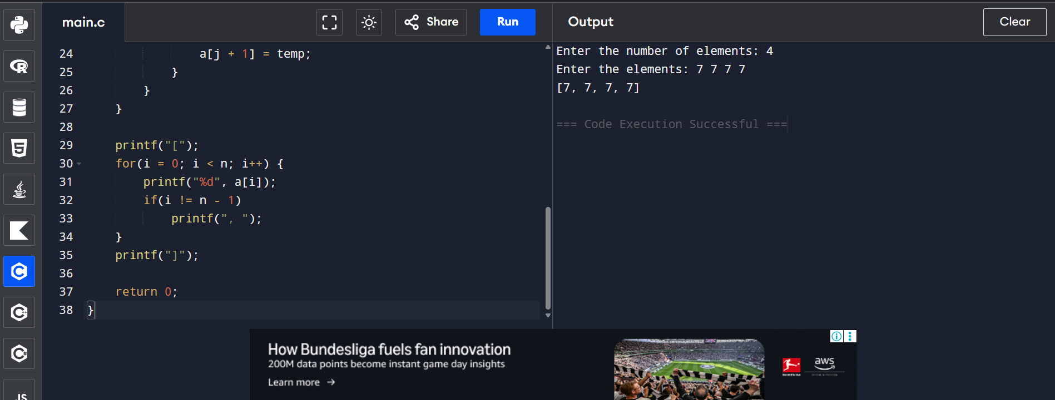
Test Case 3: All Identical Elements
Input:
Enter the number of elements: 4
Enter the elements: 7 7 7 7
Output: [7, 7, 7, 7]

Test Case 4: Negative Numbers
Input:
Enter the number of elements: 5
Enter the elements: -5 -1 -3 -2 -4
Output:
[-5, -4, -3, -2, -1]
Time Complexity
- Best Case: O(n²)
- Average Case: O(n²)
- Worst Case: O(n²)

Space Complexity
- O(1) (Constant extra space)

Result:The program successfully sorts the given list of integers in ascending order and correctly handles an empty list, a single-element list, identical elements, and negative numbers.

2. Describe the Selection Sort algorithm's process of sorting an array. Selection
Sort works by dividing the array into a sorted and an unsorted region.
Initially, the sorted region is empty, and the unsorted region contains all
elements. The algorithm repeatedly selects the smallest element from the
unsorted region and swaps it with the leftmost unsorted element, then
moves the boundary of the sorted region one element to the right. Explain

why Selection Sort is simple to understand and implement but is inefficient
for large datasets. Provide examples to illustrate step-by-step how Selection
Sort rearranges the elements into ascending order, ensuring clarity in your
explanation of the algorithm's mechanics and effectiveness.
Sorting a Random Array:
Input: [5, 2, 9, 1, 5, 6]
Output: [1, 2, 5, 5, 6, 9]
Sorting a Reverse Sorted Array:
Input: [10, 8, 6, 4, 2]
Output: [2, 4, 6, 8, 10]
Sorting an Already Sorted Array:
Input: [1, 2, 3, 4, 5]
Output: [1, 2, 3, 4, 5]

Aim
To write a C program to sort an array in ascending order using the Selection Sort algorithm.

Screen shots of code:

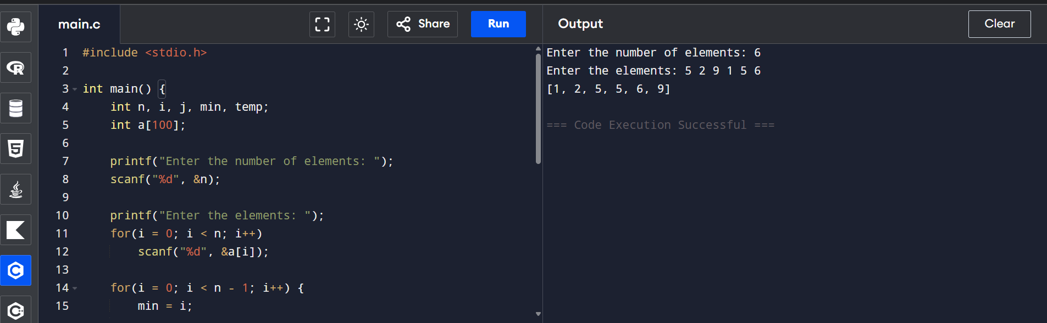
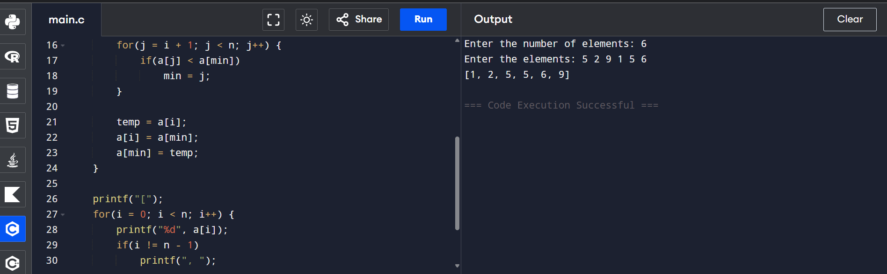
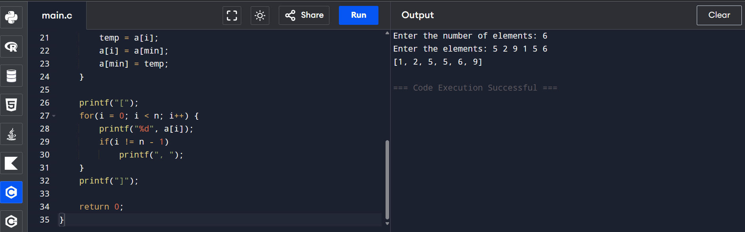
Test Case 1: Sorting a Random Array
Input:
Enter the number of elements: 6
Enter the elements: 5 2 9 1 5 6
Output:
[1, 2, 5, 5, 6, 9]
Test Case 2: Sorting a Reverse Sorted Array
Input:
Enter the number of elements: 5
Enter the elements: 10 8 6 4 2
Output:
[2, 4, 6, 8, 10]
Test Case 3: Sorting an Already Sorted Array
Input:
Enter the number of elements: 5
Enter the elements: 1 2 3 4 5
Output:
[1, 2, 3, 4, 5]
Time Complexity
- Best Case: O(n²)
- Average Case: O(n²)
- Worst Case: O(n²)

Space Complexity
- O(1) (Constant extra space)

Result
The program successfully sorts the given array in ascending order using the Selection Sort algorithm. It correctly handles random, reverse sorted, and already sorted arrays while demonstrating the working of Selection Sort.

3. Write code to modify bubble_sort function to stop early if the list becomes
sorted before all passes are completed.
Test Cases:
• Test your optimized function with the following lists:
1. Input: [64, 25, 12, 22, 11]
• Expected Output: [11, 12, 22, 25, 64]
2. Input: [29, 10, 14, 37, 13]
• Expected Output: [10, 13, 14, 29, 37]
3. Input: [3, 5, 2, 1, 4]
• Expected Output: [1, 2, 3, 4, 5]
4. Input: [1, 2, 3, 4, 5] (Already sorted list)
• Expected Output: [1, 2, 3, 4, 5]
5. Input: [5, 4, 3, 2, 1] (Reverse sorted list)
• Expected Output: [1, 2, 3, 4, 5]

Aim
To write a C program to sort an array in ascending order using an optimized Bubble Sort algorithm that stops early if the array becomes sorted before all passes are completed.
Screen shots of code:
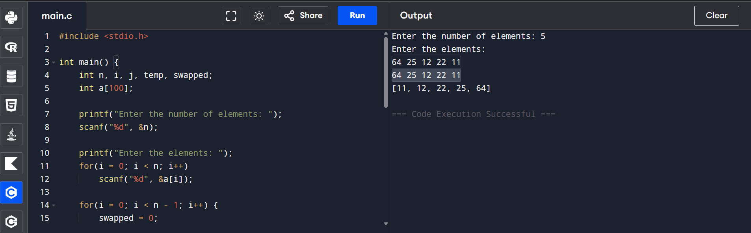
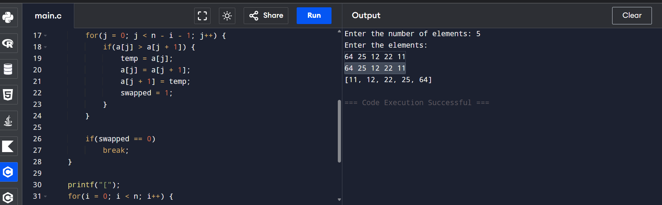

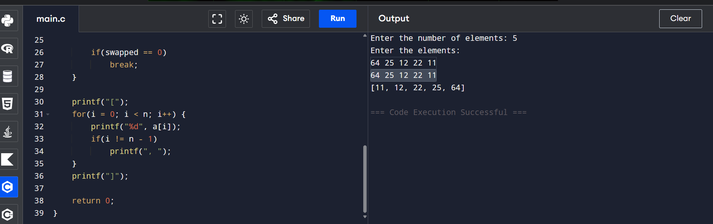
Test Case 1
Input
Enter the number of elements: 5
Enter the elements: 64 25 12 22 11
Output
[11, 12, 22, 25, 64]

Test Case 2
Input
Enter the number of elements: 5
Enter the elements: 29 10 14 37 13
Output
[10, 13, 14, 29, 37]

Test Case 3
Input
Enter the number of elements: 5
Enter the elements: 3 5 2 1 4
Output
[1, 2, 3, 4, 5]

Test Case 4 (Already Sorted List)
Input
Enter the number of elements: 5
Enter the elements: 1 2 3 4 5
Output
[1, 2, 3, 4, 5]

Test Case 5 (Reverse Sorted List)
Input
Enter the number of elements: 5
Enter the elements: 5 4 3 2 1
Output
[1, 2, 3, 4, 5]
Time Complexity
- Best Case: O(n) (Already sorted)
- Average Case: O(n²)
- Worst Case: O(n²)

Space Complexity
- O(1) (Constant extra space)

Result
The program successfully sorts the given array in ascending order using the optimized Bubble Sort algorithm. It correctly handles random, already sorted, and reverse sorted arrays, and improves efficiency by stopping early when no swaps are required.

4.Write code for Insertion Sort that manages arrays with duplicate
elements during the sorting process. Ensure the algorithm's behavior
when encountering duplicate values, including whether it preserves the
relative order of duplicates and how it affects the overall sorting
outcome.
Examples:
1. Array with Duplicates:
• Input: [3, 1, 4, 1, 5, 9, 2, 6, 5, 3]
• Output: [1, 1, 2, 3, 3, 4, 5, 5, 6, 9]
2. All Identical Elements:
• Input: [5, 5, 5, 5, 5]
• Output: [5, 5, 5, 5, 5]
3. Mixed Duplicates:
• Input: [2, 3, 1, 3, 2, 1, 1, 3]
• Output: [1, 1, 1, 2, 2, 3, 3, 3]

Aim
To write a C program to sort an array in ascending order using the Insertion Sort algorithm and handle duplicate elements while preserving their relative order.
Screen shots of code:
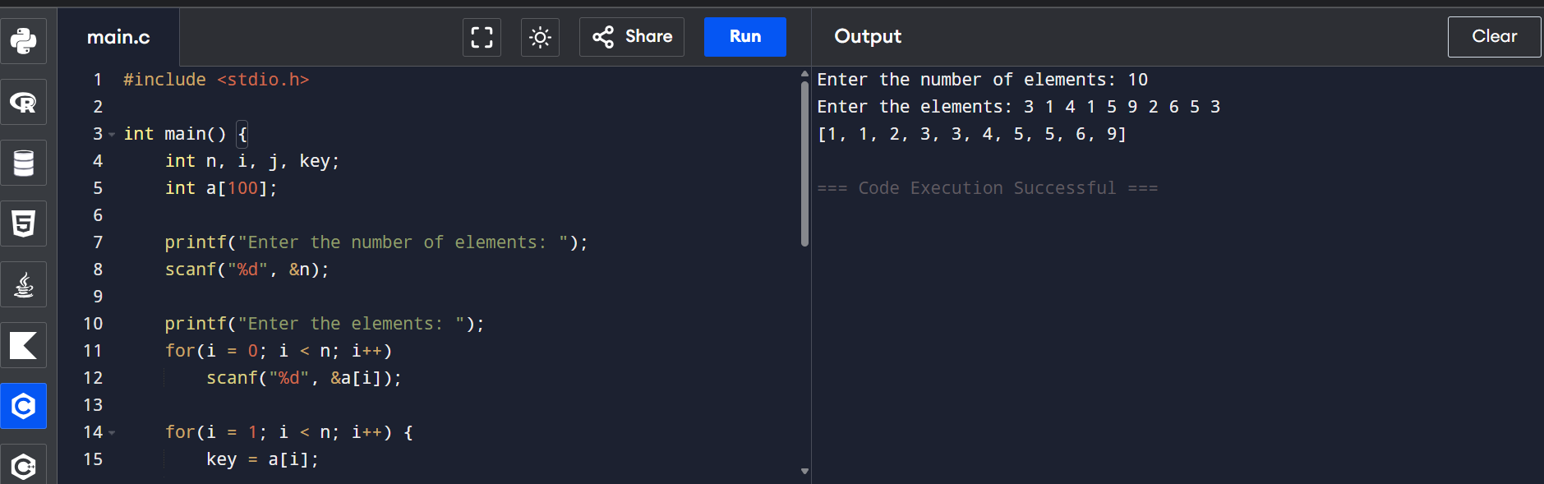
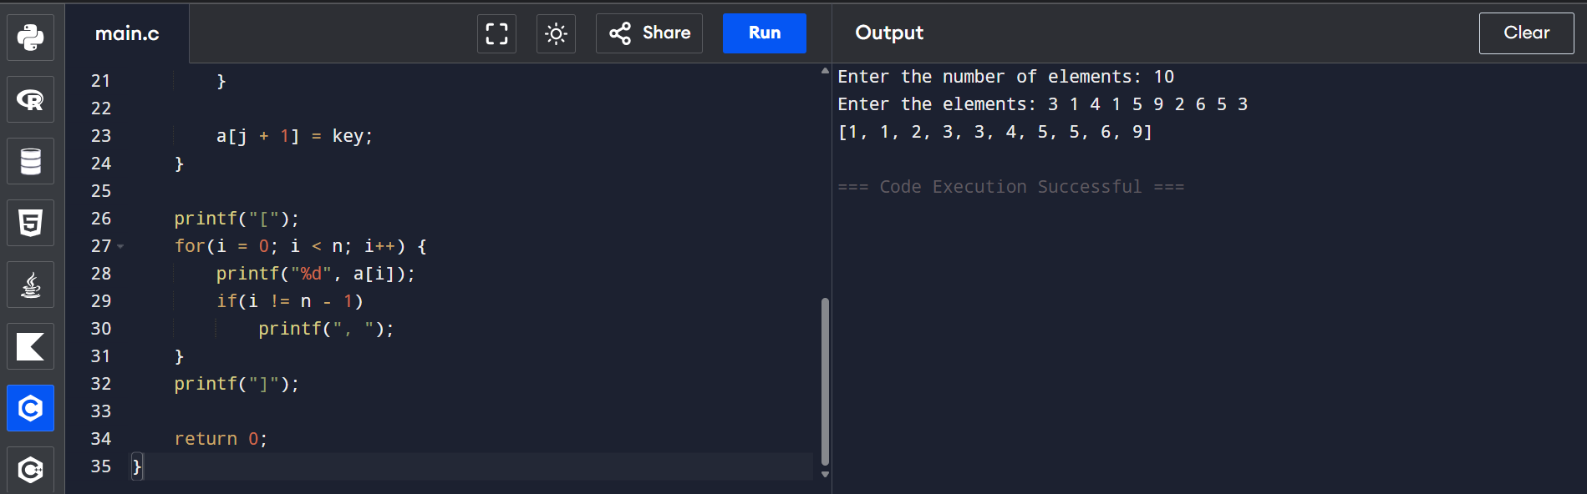
Test Case 1: Array with Duplicates
Input
Enter the number of elements: 10
Enter the elements: 3 1 4 1 5 9 2 6 5 3
Output
[1, 1, 2, 3, 3, 4, 5, 5, 6, 9]

Test Case 2: All Identical Elements
Input
Enter the number of elements: 5
Enter the elements: 5 5 5 5 5
Output
[5, 5, 5, 5, 5]

Test Case 3: Mixed Duplicates
Input
Enter the number of elements: 8
Enter the elements: 2 3 1 3 2 1 1 3
Output
[1, 1, 1, 2, 2, 3, 3, 3]
Time Complexity
- Best Case: O(n) (Already sorted)
- Average Case: O(n²)
- Worst Case: O(n²)

Space Complexity
- O(1) (Constant extra space)

Result
The program successfully sorts the array in ascending order using the Insertion Sort algorithm. It correctly handles duplicate elements while preserving their relative order, making Insertion Sort a stable sorting algorithm suitable for small and nearly sorted datasets.

